Paul R. LePage GOVERNOR

May 22, 2017
S T A T E OF M AINE
STAT E HO US E STAT ION
AUGUSTA, MAINE 0 4 3 3 0 -
0 0 5 4

Members of Employment First Maine Coalition Elaine Ecker, Chair
c/o Disability Rights Maine 24 Stone Street, Suite 204
Augusta, ME 04330

Re: Final Employment First Maine Coalition Report and Recommendations Dear Members:
The Departments of Education, Health and Human Services, and Labor wish to acknowledge and applaud the dedication and three-year commitment of the Employment First Maine Coalition to fulfill the requirements of L.D. 1352, An Act to Provide Integrated Community-Based Employment and Customized Employment for Persons with Disabilities. The final report submitted to the Governor, Legislature and State Agencies captures well the challenges and opportunities that exist in truly making employment the first and preferred service or support option for individuals with disabilities in Maine.

The Departments have reviewed the Coalition's recommendations regarding how the policy vision and goals of the Employment First Maine Act can be accomplished. It is evident that the achievement of improved employment outcomes for this population goes far beyond state agencies and must involve persons with disabilities themselves, their families, the business community, educational systems, advocacy groups, and service provider agencies. The report's recommendations need to be prioritized and oversight carried forward even as the Coalition sunsets. To that end, we commit to supporting the continued focus collectively to improve the employment of people with disabilities in Maine.

We, the Departments, commit to continuing our tri-agency efforts to develop a cross-department data system that includes tracking outcomes for people who are employed and those who are on the pathway to employment. Furthermore, we commit to encouraging an expectation of employment for those we serve by connecting businesses to a qualified workforce, individuals to supports that allow them to be successful, and to develop opportunities for providers who have a vital role in employment outcomes. We know that young people with disabilities graduating
from school are part of the solution to our pending workforce issues. Together, DHHS, DOL and DOE know that preparing and supporting our jointly served people to enter and be successful in employment is critical work that we must do in concert with a broader group, including those that worked to develop the Employment First recommendations.

We thank the committed citizens who worked for three years on the Employment First Coalition to analyze, review, and recommend changes to support the increased employment of people with disabilities. Their work shows the pathway forward to become an Employment First state. We are steadfast in our belief that people with disabilities have talents and abilities that can benefit Maine employers while enriching their own lives when engaged in employment.

Respectfully,

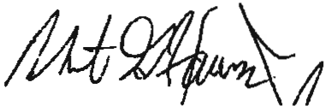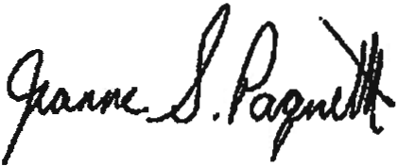

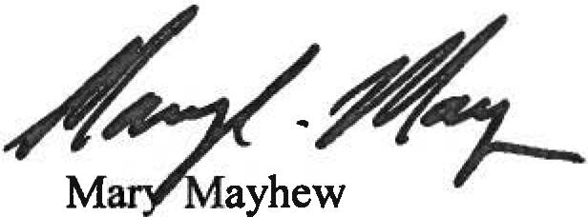
DHHS Commissioner
Robert Hasson
DOE Commissioner
Jeanne Paquette DOL Commissioner

