STATE OF MAINE
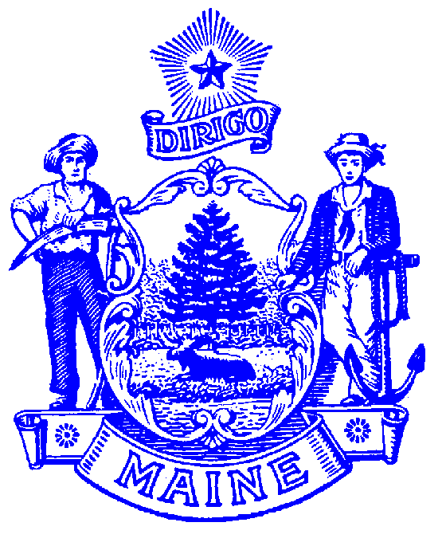
DEPARTMENT OF LABOR

JOHN BUTERA
COMMISSIONER

54 STATE HOUSE STATION
AUGUSTA, MAINE 04333-0054

PAUL R. LEPAGE
GOVERNOR

February 28, 2018

Senator Amy Volk, Chair
Representative Ryan Fecteau, Chair
State of Maine 128th Legislature
Committee on Labor, Commerce, Research and Economic Development

Re: Employment First Maine Coalition Report and Recommendations

Dear Senator Volk, Representative Fecteau and Committee Members:

In the letter dated January 18, 2018 requesting an update on our efforts related to Public Law Title 26, Chapter 41, The Employment First Maine Act the Departments of Labor, Health and Human Services and Education are jointly providing the attached report.

The report highlights some of the many employment activities underway, including those which address recommendations identified in the Employment First Maine Coalition’s final report submitted to The Labor Committee on January 16th, 2018.

The Departments appreciate the Committee’s support of the employment of people with disabilities in Maine and efforts across the state by individuals with disabilities, families, the business community, educational systems, advocacy groups, and service provider agencies, to achieve the vision of The Employment First Maine Act. Together, we know that preparing and supporting this untapped workforce and the employers who need them is important for Maine.

Sincerely,

John Butera Ricker Hamilton Robert Hasson
DOL Commissioner DHHS Commissioner DOE Commissioner

Enclosure

